- What are the sources of power dissipation in CMOS inverter?Also explain the clock gating?
- Explain parasitic delay? Calculate the parasitic delay of the inverter?
- Explain different types of inverter delays?
- How are rise time and fall time related to :
  - Load capacitance(CL)
  - Vdd
- What is the effect on the switching point when Bp/Bn ratio is increased?
6.
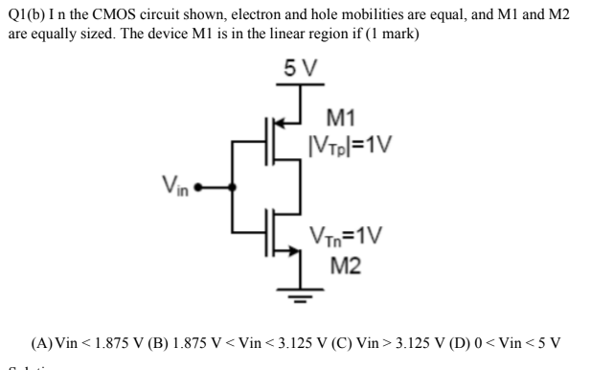
7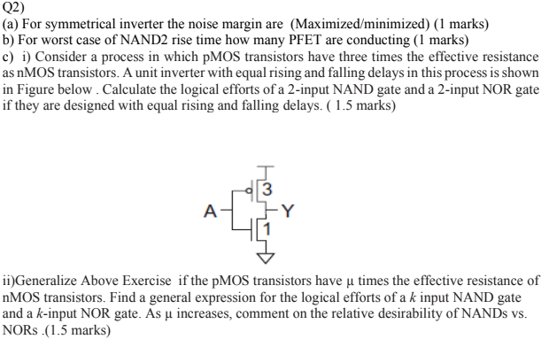

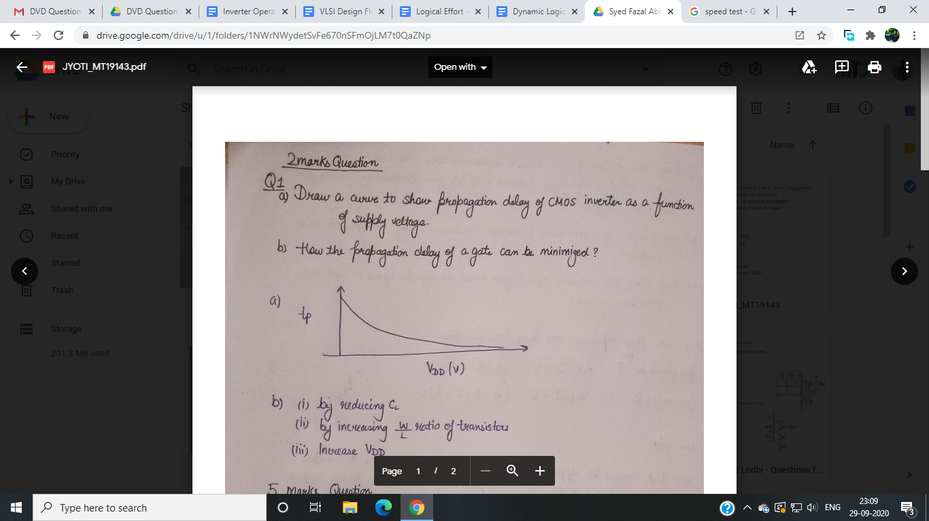
8.

9.
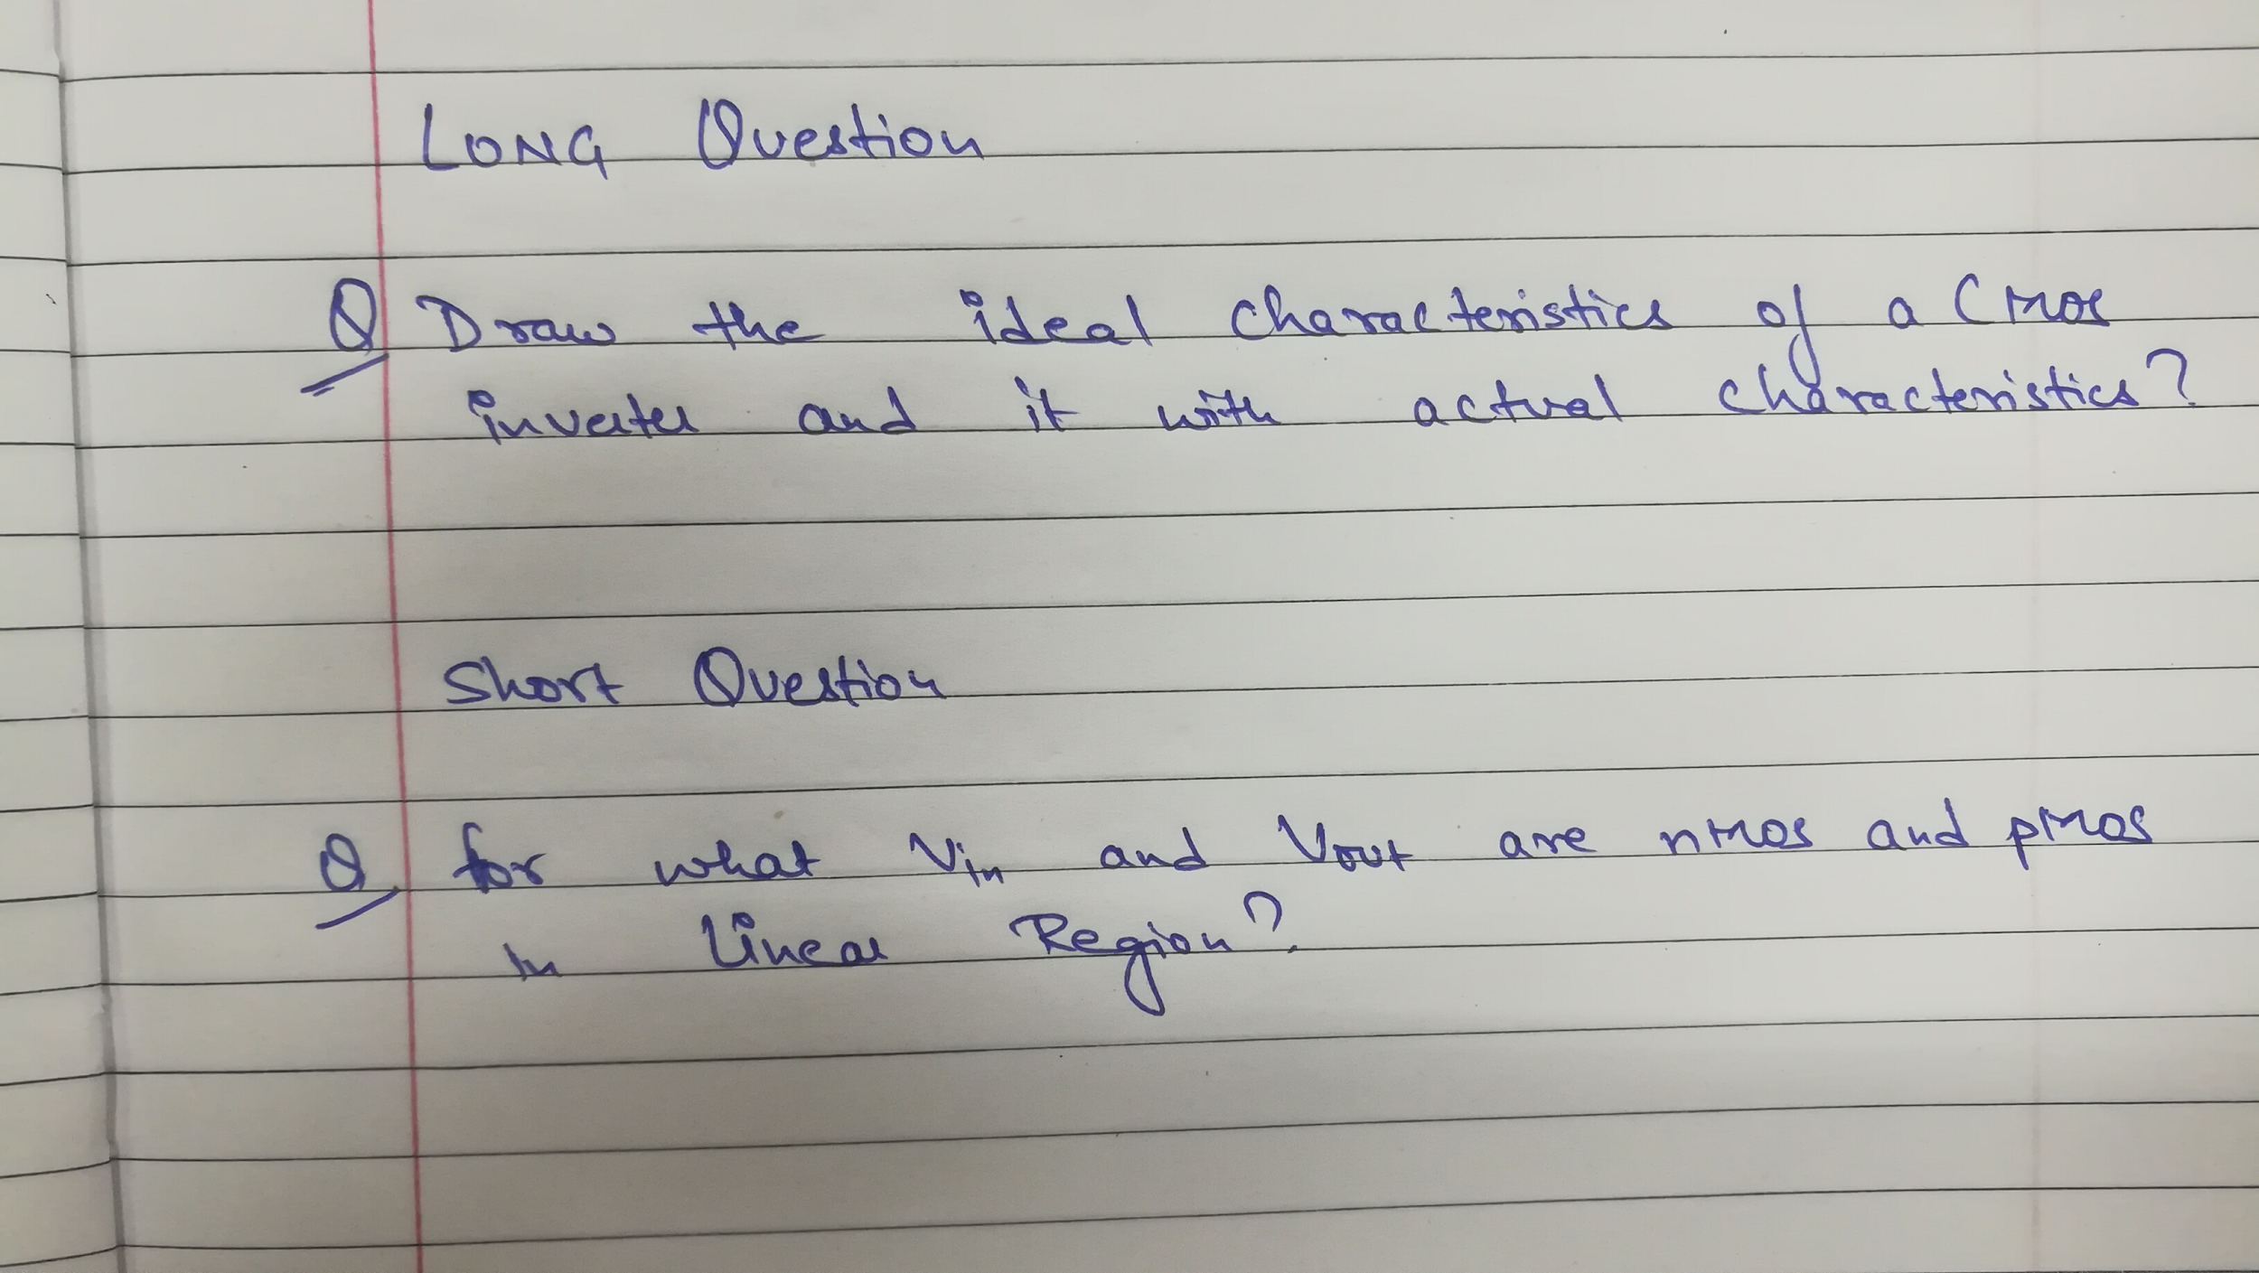

10.
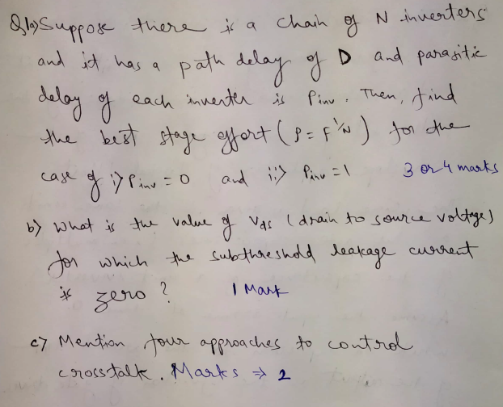

11.Find elmore delay for a fan out of 5 inverter ?
12
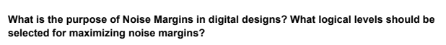
13
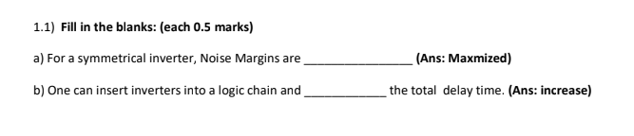

14
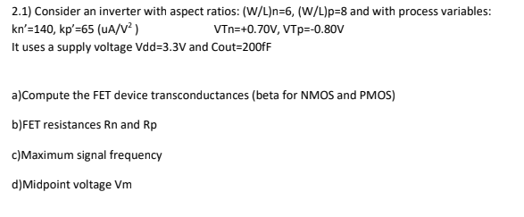

15.Draw the ideal characteristics of a CMOS inverter and it with actual characteristics?

16.For what Vin and Vout nmos and pmos are in linear region?
17. A ring oscillator is formed by connecting nine inverters in a loop.Find the delay times of the inverter for an ideal pulse which has a voltage swing changing between Vol and Voh, the rise and the fall times and also the oscillation frequency.
18. What is the effect on the switching point when Bp/Bn ratio is increased?

19)
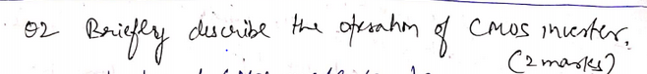.

20)
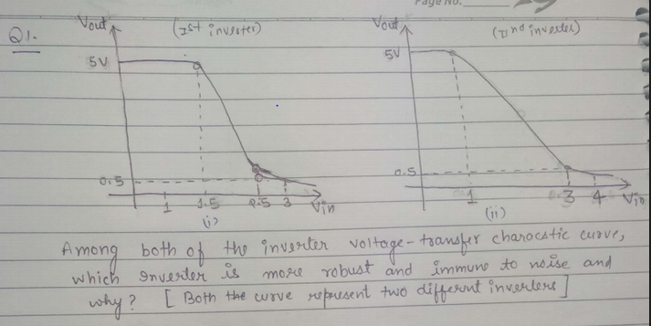

21)
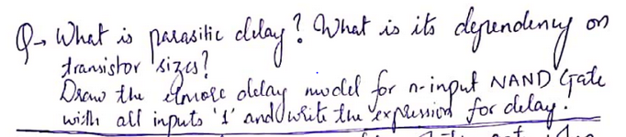

22)
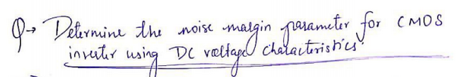
23)
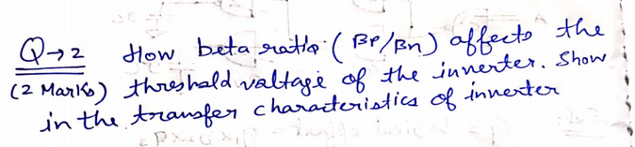

24)
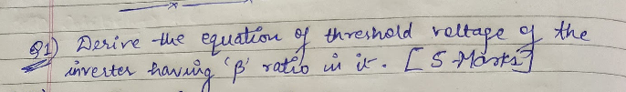
25)
Derive threshold voltage for long channel CMOS INVERTER . (2M)
26)
Find Out the expression of delay time in cmos inverter ? Explain some ways to reduce the delay time in a cmos inverter?
27)
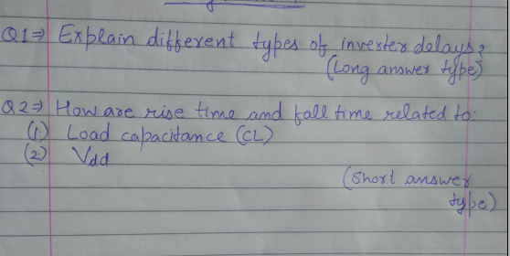
28)
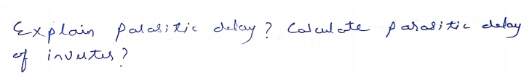
29)
Find the frequency of 25-stage ring oscillator that is constructed from inverters.
30)
Calculate the contamination delay for a 3 input NOR gate using CMOS if it is sized with effective rise and fall time equal to unit inverter
31.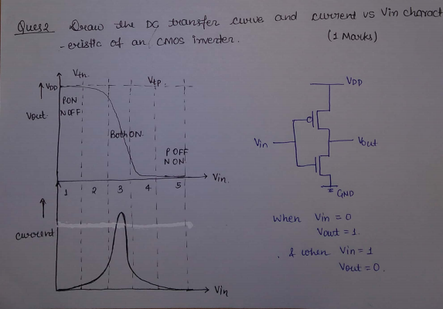
32
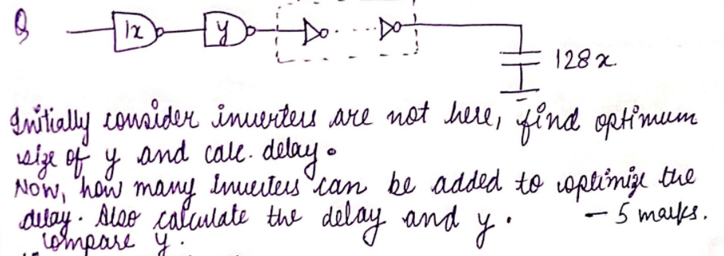

33.
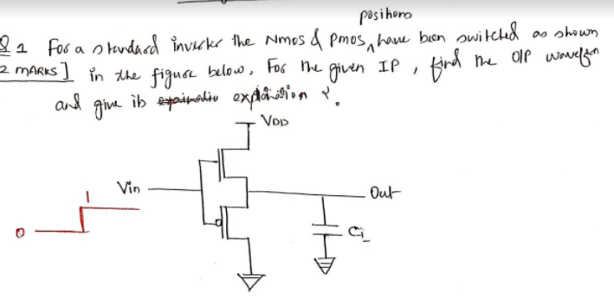
34
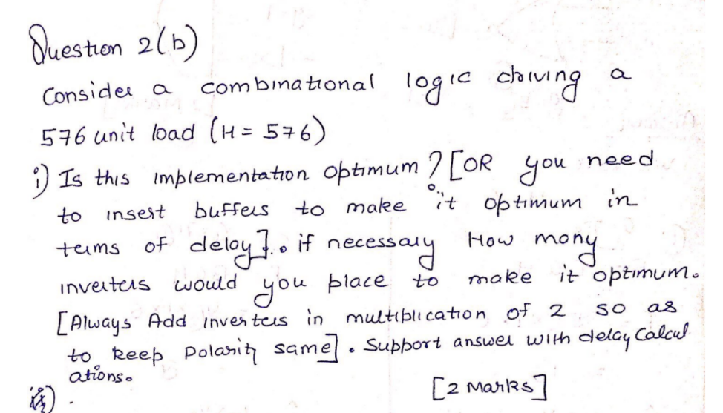

35 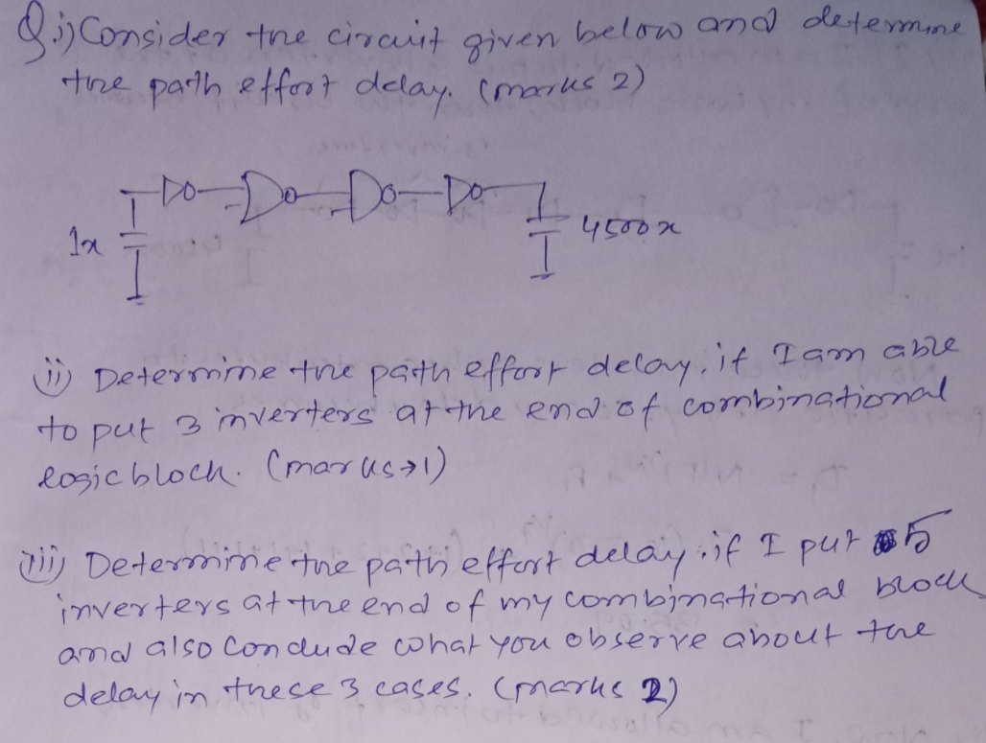

36 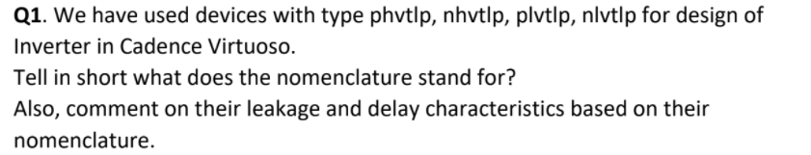

37 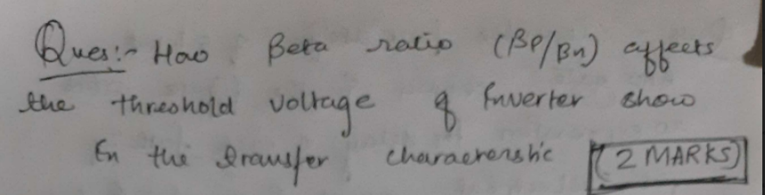

38 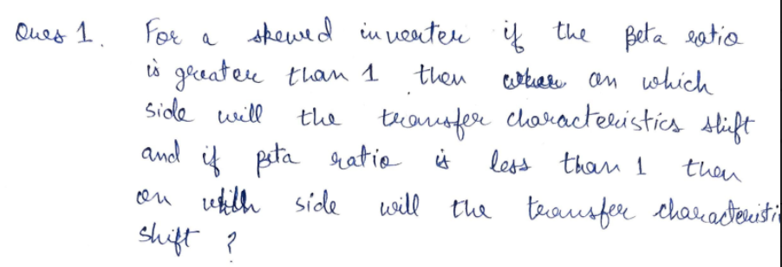

39 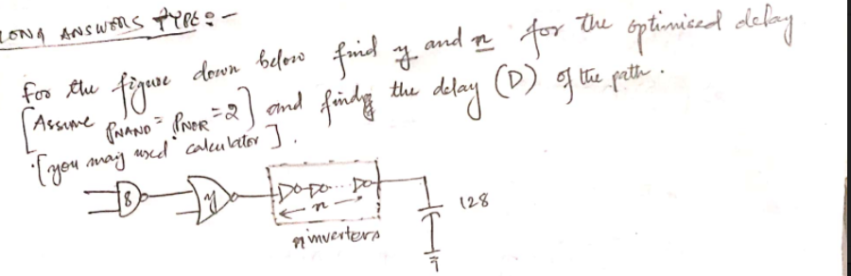
40 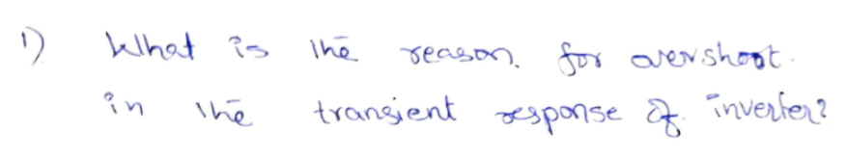
41. 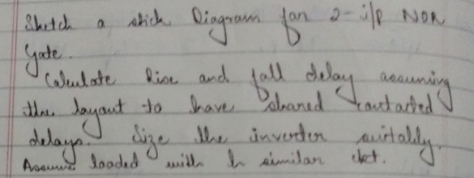

42 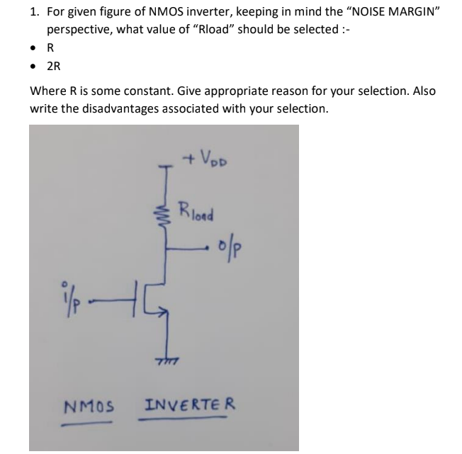
43 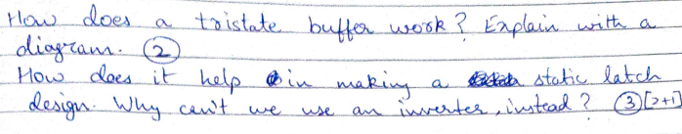
44 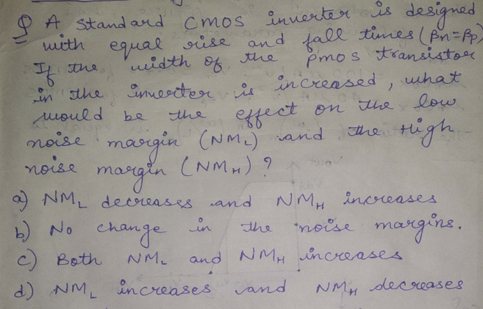
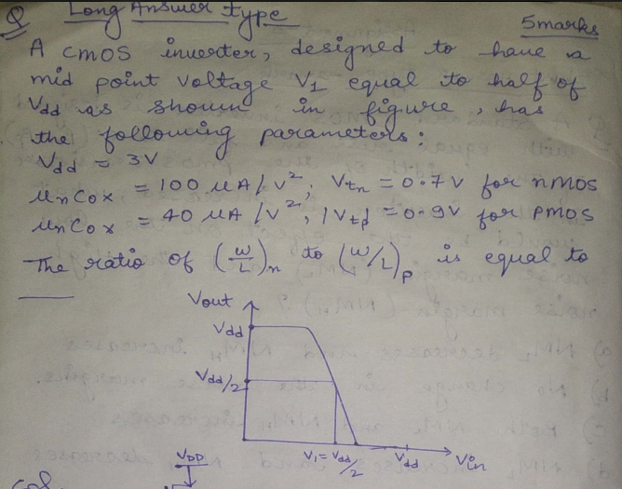
45

46

